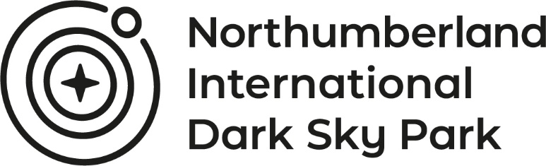

Application Form: Dark Sky Stay and Gaze Business
Essential: Please confirm that you have done the following (by deleting the response that does not apply):
- Behave proactively in reducing light pollution on your property or nearby Y/N
- Accept late returns from star-gazing events or activities Y/N
- Are flexible with guests – consider requests for late check out or breakfasts Y/N
- Consider how star-gazing guests will interact with other guests – for example returning late and making noise. Y/N
- Provide guests with a checklist of what to bring to enjoy the night skies Y/N
- Provide information: e.g., leaflets, star charts, reference books, websites, iPad & apps etc Y/N
- Promote star gazing activities and events in Northumberland on websites, in literature, emails, social media and face to face. Y/N
- If the business is located within the International Dark Sky Park use the Park logo. Y/N
- Provide a designated viewing area on-site with appropriate outside lighting which should be minimal but still ensure the safety of guests. Y/N
- Provide equipment that guests can use to view the stars – e.g., binoculars, red torches, telescopes etc. Y/N
Not essential: Please indicate if you have done any of these additional actions
- Provide facilities for refreshments – on return or as packed meals Y/N
- Give advice and tips (e.g., paint normal torches with red nail varnish) Y/N
- Attend a ‘Star Tips for Profit’ astro-tourism workshop or other training Y/N
Confirmed by:
Name:
Business name:
Telephone number:
Please note these awards are applicable to businesses that advertise on vistnorthumberland.com as a way of visitors finding Dark Sky Friendly accommodation providers. Successful applications will be awarded “Dark Sky Friendly” or “Dark Sky Stay & Gaze” status. It is the responsibility of the business to ensure that they are meeting the essential criteria required of the awards at all times. Any business reported not to be complying with the essential criteria will be subject to the complaint’s procedure.

